T04: (Paste your web link for T04-7 here)

T05: (Paste your web link for T05 here)

T06: https://cos30045datavisualisationt06.vercel.app

T07: Data Visualisation Design

Visualisation 1:
Website: (Not accessible anymore) https://www.reddit.com/r/DankLeft/comments/hwcf7v/slavery_was_never_abolished_in_the_us_its_still/
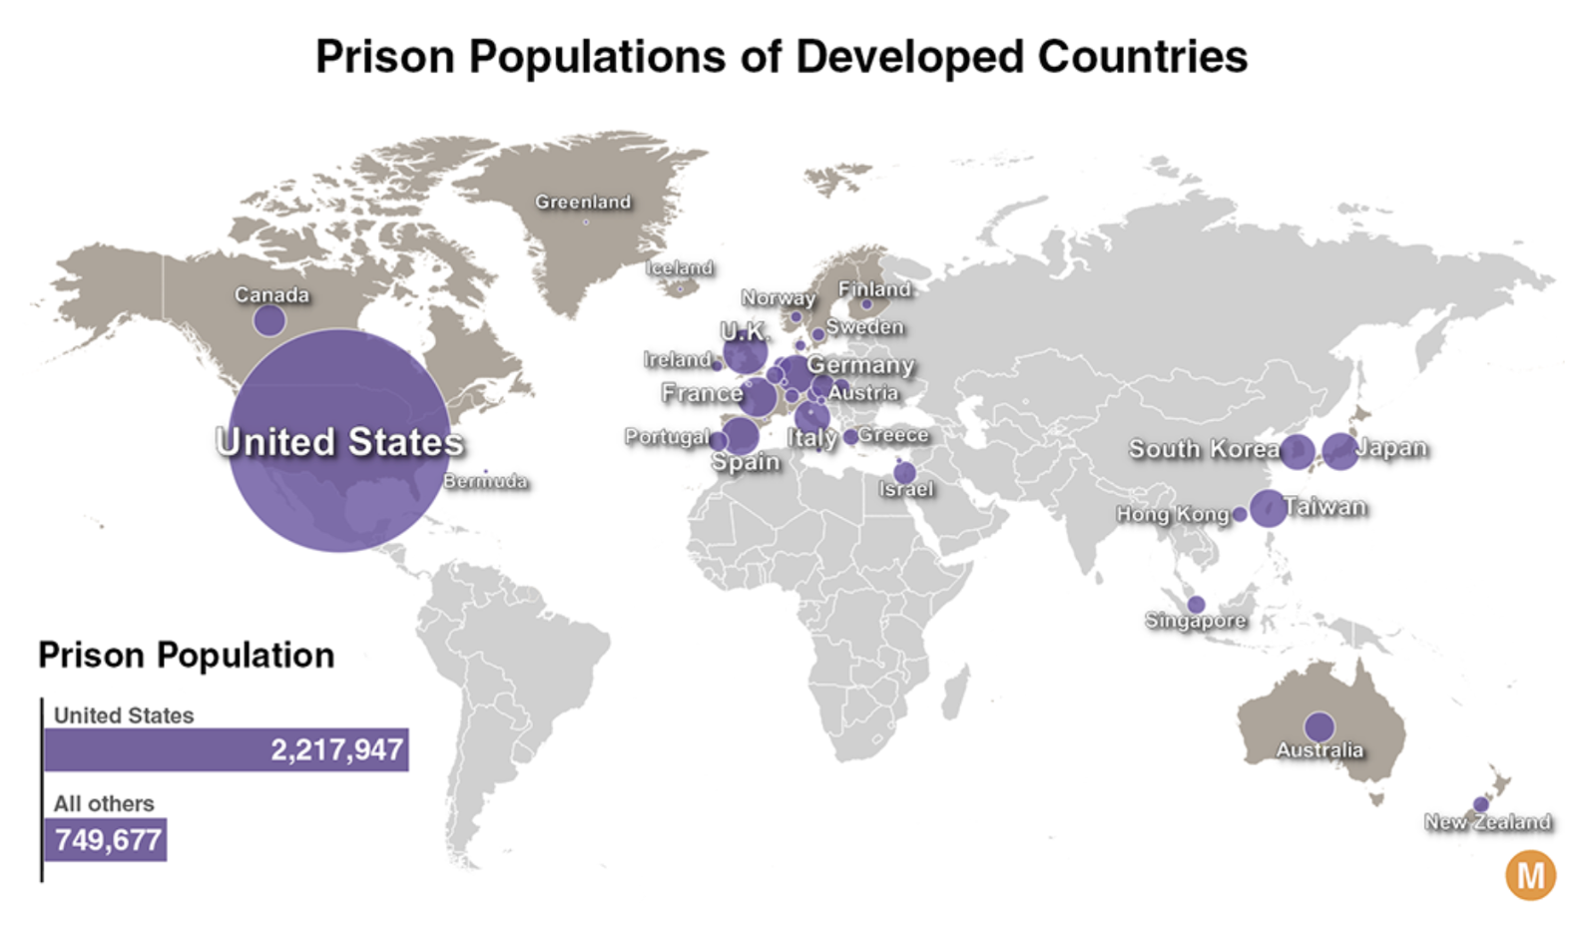

1. What appears to be the purpose of the chart?

The chart compares () and highlights that the ( ) has more prisoners than all the other countries shown combined.

2. What kind of chart is this?
A ( ), with a supporting ( ).

3. What data does it appear to be encoding and how is it encoding it?
Data encoded | Encoding method | Explanation
Prison population of each country | Choose an item. | Choose an item.
Country location | Choose an item. | Choose an item.
Country identity | Choose an item. | Choose an item.
Total prisoners: United States versus all others | Choose an item. | Choose an item.
Country group | Choose an item. | Choose an item.
Exact prison population totals | Choose an item. | Choose an item.

4. Are there any interactive features? If so, what are they and how are they used?
No, this chart is not interactive.

5. What features does it use to try to get its message across?
Feature | How it helps convey the message
Large U.S. bubble | Choose an item.
Geographic map layout | Choose an item.
Consistent purple colour | Choose an item.
Country labels and numerical totals | Choose an item.
Supporting bar chart | Choose an item.
Prominent title and U.S. label | Choose an item.

6. Which design do you think is best and why?

Design feature | Good design | Bad design
The bar chart clearly compares the U.S. total with all others combined. | ☐ | ☐
Overlapping labels make some European countries difficult to identify. | ☐ | ☐
Numerical labels show exact prison population totals. | ☐ | ☐
Overlapping bubbles make smaller populations difficult to compare. | ☐ | ☐
The map provides geographic context. | ☐ | ☐
The title clearly identifies the chart’s topic. | ☐ | ☐

Visualisation 2:
Website: https://www.pewresearch.org/short-reads/2021/08/16/americas-incarceration-rate-lowest-since-1995
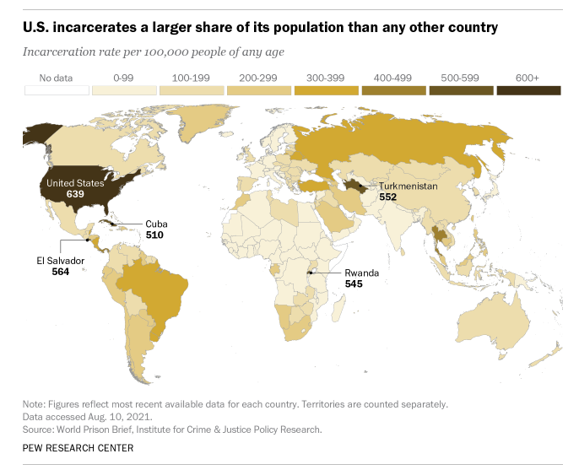

1. What appears to be the purpose of the chart?
The chart compares ( ) across countries and highlights that the ( ) has the highest rate in the data presented.

2. What kind of chart is this?
A ( ).

3. What data does it appear to be encoding and how is it encoding it?
Data Encoded | Encoding Method | Explanation
Incarceration rate per 100,000 people | Choose an item. | Choose an item.
Country location | Choose an item. | Choose an item.
Selected countries and exact rates | Choose an item. | Choose an item.
Missing data | Choose an item. | Choose an item.

4. Are there any interactive features? If so, what are they and how are they used?
No, this chart is static.

5. What features does it use to try to get its message across?
Feature | How it helps
Sequential colour scale | Choose an item.
World map layout | Choose an item.
Country names and numerical labels | Choose an item.
Prominent headline | Choose an item.
Colour legend | Choose an item.
Subtitle and source notes | Choose an item.

6. Which design do you think is best and why?
Design feature | Good design | Bad design
Rates per 100,000 people support comparisons between countries of different population sizes. | ☐ | ☐
Ordered light-to-dark colours communicate increasing rates. | ☐ | ☐
Countries within the same colour range cannot be distinguished by shade alone. | ☐ | ☐
Selected numerical labels provide exact rates. | ☐ | ☐
Small countries are difficult to see on the world map. | ☐ | ☐
The headline clearly communicates the main finding. | ☐ | ☐

Visualisation 3:
Website: https://worldpopulationreview.com/country-rankings/incarceration-rates-by-country
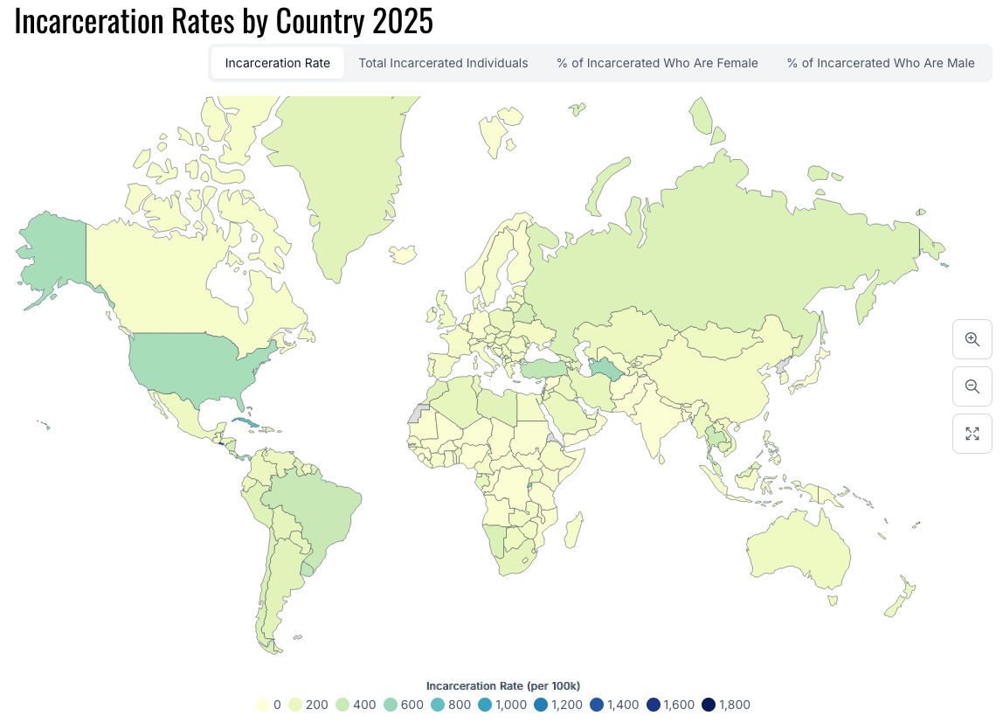

1. What appears to be the purpose of the chart?
The chart compares ( ) in year ( ), helping viewers identify geographic differences.

2. What kind of chart is this?
A ( ).

3. What data does it appear to be encoding and how is it encoding it?
Data encoded | Encoding | Explanation
Incarceration rate | Choose an item. | Choose an item.
Country location | Choose an item. | Choose an item.
The legend explains the colour scale, ranging from 0 to 1,800 prisoners per 100,000 people.

4. Are there any interactive features? If so, what are they and how are they used?
Feature | Intended use
Zoom and pan controls | Choose an item.
Hover tooltips | Choose an item.

5. What features does it use to try to get its message across?
Feature | How It Helps Convey the Message
Sequential color scale | Choose an item.
Interactive filters | Choose an item.
World map layout | Choose an item.
Colour legend | Choose an item.
Zoom controls | Choose an item.
Chart tile | Choose an item.

6. Which design do you think is best and why?
Design feature | Good design | Bad design
Rates per 100,000 support comparisons across countries of different population sizes. | ☐ | ☐
The legend links colours to numerical rates. | ☐ | ☐
Many countries have similar pale colours, making differences difficult to distinguish. | ☐ | ☐
Tabs allow users to explore different measures. | ☐ | ☐
Small countries are difficult to identify in the global view. | ☐ | ☐
The data source is provided, helping viewers verify the information. | ☐ | ☐

Visualisation 4:
Reference: https://www.prisonpolicy.org/global/2024.html
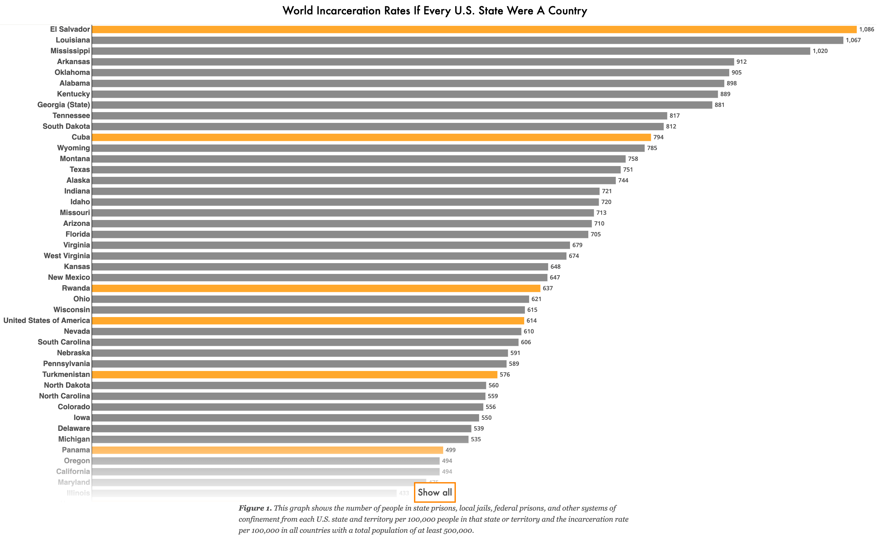

1. What appears to be the purpose of the chart?
The chart compares (the incarceration rate between US States and other countries), showing that many U.S. states have rates higher than those of numerous countries.

2. What kind of chart is this?
A (horizontal bar chart), ordered from highest to lowest rate.

3. What data does it appear to be encoding and how is it encoding it?
Data Encoded | Encoding Method | Explanation
Incarceration rate per 100,000 people | Bar length | C. Longer bars indicate higher rates.
State or country identity | Text labels | D. Names identify each state or country.
Category (U.S. state vs country) | Hue Colors | A. Grey represents states; orange represents countries, including the U.S. total.
Exact incarceration rate | Numerical labels | B. Numbers at bar ends show exact rates.

4. Are there any interactive features? If so, what are they and how are they used?
Yes, there are two interactive features.
Interactive feature | Description
“Show all” button | Choose an item.
Hover tooltip | Choose an item.

5. What features does it use to try to get its message across?
Feature | How It Helps Convey the Message
Bar lengths | Choose an item.
Grey and orange colours | Choose an item.
Descending order | Choose an item.
Names and numerical labels | Choose an item.
Explanatory caption | Choose an item.
Horizontal layout | Choose an item.

6. Which design do you think is best and why?
Design feature | Good design | Bad design
Bars share a common baseline, making rates easy to compare. | ☐ | ☐
Descending order makes the ranking clear. | ☐ | ☐
Contrasting colours distinguish states from countries. | ☐ | ☐
Small text makes names and values difficult to read at the displayed size. | ☐ | ☐
The visualization lacks a colour legend explicitly explaining grey and orange. | ☐ | ☐
Numerical labels provide exact rates without requiring estimates. | ☐ | ☐

Visualisation 5:
Reference: https://www.prisonpolicy.org/global/2024.htmlLinks to an external site. (scroll down)
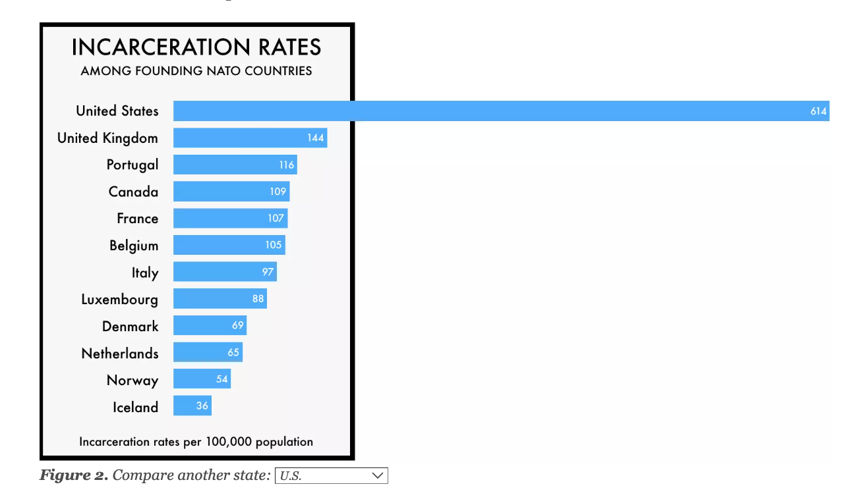

1. What appears to be the purpose of the chart?
The chart compares (incarceration rates between US states and NATO countries) highlighting the much higher U.S. rate compared with the other countries shown.

2. What kind of chart is this?
A (horizontal bar chart), ordered from highest to lowest rate.

3. What data does it appear to be encoding and how is it encoding it?
Data Encoded | Encoding Method | Explanation
Incarceration rate per 100,000 population | Bar length | Longer bars indicate higher rates.
Country name | Text labels | Names identify each country.
Exact incarceration rate | Numerical labels | Values inside bars show exact rates.
Ranking | Vertical position | Higher rates appear nearer the top.

4. Are there any interactive features? If so, what are they and how are they used?
Yes. The chart includes an interactive dropdown below the bars.
Interactive feature | How it is used
State selection dropdown | Select a U.S. state to replace the national U.S. bar with that state’s incarceration rate.
Dynamic chart update | Compare the selected state’s rate with those of the founding NATO countries.

5. What features does it use to try to get its message across?
Feature | How it helps — answer
Long U.S. bar | Emphasises the much higher U.S. rate.
Consistent blue colour | Keeps attention on bar-length differences.
Descending order | Makes the highest and lowest rates easy to identify.
Country names and numerical labels | Identifies countries and shows exact rates.
Interactive dropdown | Allows users to customise the comparison.
Title and rate caption | Identifies the comparison group and measurement unit.

6. Which design do you think is best and why?
Design feature | Good design | Bad design
Bars share a common baseline, supporting accurate comparison. | ☐/ | ☐
Descending order makes the ranking clear. | ☐/ | ☐
Numerical labels provide exact rates. | ☐/ | ☐
The heavy black border adds clutter and cuts through the bar area. | ☐ | ☐/
The caption clearly states the measurement unit. | ☐/ | ☐
The data source is not provided. | ☐ | ☐/

